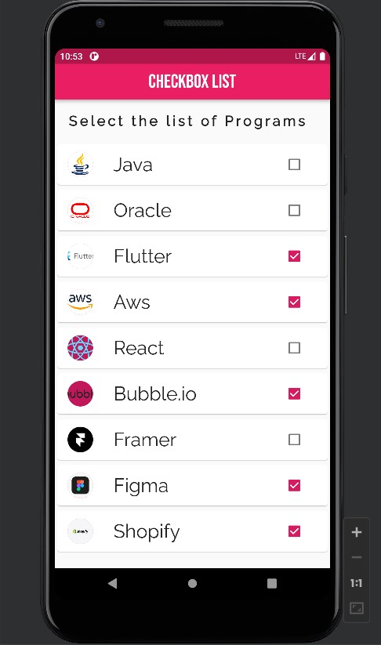

import 'package:flutter/cupertino.dart';  
import 'package:flutter/material.dart';  
  
void main() {  
 runApp(ChckBoxx());  
}  
  
class ChckBoxx extends StatefulWidget {  
 const ChckBoxx({super.key});  
  
 @override  
 State<StatefulWidget> createState() => _ChckBoxx();  
}  
  
class _ChckBoxx extends State<ChckBoxx> {  
 bool Java = false;  
 bool flutter = false;  
 bool Oracle = false;  
 bool Webflow = false;  
 bool Aws = false;  
 bool React = false;  
 bool Shopify = false;  
 bool Bubble = false;  
 bool Framer = false;  
 bool Figma = false;  
  
  
 @override  
 Widget build(BuildContext context) {  
 return MaterialApp(  
 debugShowCheckedModeBanner: false,  
 theme: ThemeData(  
 primarySwatch: Colors.*pink*,  
 ),  
 home: Scaffold(  
 appBar: AppBar(  
 title: const Text(  
 'CheckBox List',  
 style: TextStyle(fontSize: 30, fontFamily: 'BebasNeue'),  
 ),  
 centerTitle: true,  
 ),  
 body: ListView(  
 children: [  
 const Padding(  
 padding: EdgeInsets.all(20),  
 child: Text(  
 'Select the list of Programs',  
 style: TextStyle(  
 fontFamily: 'Raleway',  
 fontSize: 22,  
 fontWeight: FontWeight.*bold*,  
 letterSpacing: 4),  
 ),  
 ),  
 Card(  
 child: ListTile(  
 leading: const CircleAvatar(backgroundImage: NetworkImage('https://d3njjcbhbojbot.cloudfront.net/api/utilities/v1/imageproxy/https://coursera-course-photos.s3.amazonaws.com/0a/8cd7f1b14344618b75142593bc7af8/JavaCupLogo800x800.png?auto=format%2Ccompress&dpr=1'),  
 ),  
 title: CheckboxListTile(  
 checkColor: Colors.*white*,  
 title: const Text('Java', style: TextStyle(fontSize: 30, fontFamily: 'Raleway'),),  
 value: Java,  
 onChanged: (value) {  
 setState(() {  
 Java = value!;  
 });  
 },  
 ),  
 ),  
 ),  
  
 Card(  
 child: ListTile(  
 leading: const CircleAvatar(backgroundImage: NetworkImage(  
 'https://www.webopedia.com/wp-content/uploads/1997/02/Webo.OracleProfile.png' ),  
 ),  
 title: CheckboxListTile(  
 checkColor: Colors.*white*,  
 title: const Text('Oracle', style: TextStyle(fontSize: 30, fontFamily: 'Raleway'),),  
 value: Oracle,  
 onChanged: (value) {  
 setState(() {  
 Oracle = value!;  
 });  
 },  
 ),  
 ),  
 ),  
  
 Card(  
 child: ListTile(  
 leading: const CircleAvatar(backgroundImage: NetworkImage(  
 'https://storage.googleapis.com/cms-storage-bucket/70760bf1e88b184bb1bc.png'),  
 ),  
 title: CheckboxListTile(  
 checkColor: Colors.*white*,  
 title: const Text('Flutter', style: TextStyle(fontSize: 30, fontFamily: 'Raleway'),),  
 value: flutter,  
 onChanged: (value) {  
 setState(() {  
 flutter = value!;  
 });  
 },  
 ),  
 ),  
 ),  
  
 Card(  
 child: ListTile(  
 leading: const CircleAvatar(backgroundImage: NetworkImage('https://a0.awsstatic.com/libra-css/images/logos/aws_logo_smile_1200x630.png'),  
 ),  
 title: CheckboxListTile(  
 checkColor: Colors.*white*,  
 title: const Text('Aws', style: TextStyle(fontSize: 30, fontFamily: 'Raleway'),),  
 value: Aws,  
 onChanged: (value) {  
 setState(() {  
 Aws = value!;  
 });  
 },  
 ),  
 ),  
 ),  
  
 Card(  
 child: ListTile(  
 leading: const CircleAvatar(backgroundImage: NetworkImage('https://upload.wikimedia.org/wikipedia/commons/thumb/a/a7/React-icon.svg/1200px-React-icon.svg.png'),  
 ),  
 title: CheckboxListTile(  
 checkColor: Colors.*white*,  
 title: const Text('React', style: TextStyle(fontSize: 30, fontFamily: 'Raleway'),),  
 value: React,  
 onChanged: (value) {  
 setState(() {  
 React = value!;  
 });  
 },  
 ),  
 ),  
 ),  
  
 Card(  
 child: ListTile(  
 leading: const CircleAvatar(backgroundImage: NetworkImage('https://bubble.io/blog/content/images/2020/09/Logo-with-clearspace.png'),  
 ),  
 title: CheckboxListTile(  
 checkColor: Colors.*white*,  
 title: const Text('Bubble.io', style: TextStyle(fontSize: 30, fontFamily: 'Raleway'),),  
 value: Bubble,  
 onChanged: (value) {  
 setState(() {  
 Bubble = value!;  
 });  
 },  
 ),  
 ),  
 ),  
  
 Card(  
 child: ListTile(  
 leading: const CircleAvatar(backgroundImage: NetworkImage('https://pbs.twimg.com/profile_images/1469296240991125519/xpZr8yYS_400x400.jpg'),  
 ),  
 title: CheckboxListTile(  
 checkColor: Colors.*white*,  
 title: const Text('Framer', style: TextStyle(fontSize: 30, fontFamily: 'Raleway'),),  
 value: Framer,  
 onChanged: (value) {  
 setState(() {  
 Framer = value!;  
 });  
 },  
 ),  
 ),  
 ),  
  
 Card(  
 child: ListTile(  
 leading: const CircleAvatar(backgroundImage: NetworkImage('https://miro.medium.com/max/1200/1*RWriD6Jy4Ssd0rFjhLNt_w.png'),  
 ),  
 title: CheckboxListTile(  
 checkColor: Colors.*white*,  
 title: const Text('Figma', style: TextStyle(fontSize: 30, fontFamily: 'Raleway'),),  
 value: Figma,  
 onChanged: (value) {  
 setState(() {  
 Figma = value!;  
 });  
 },  
 ),  
 ),  
 ),  
  
 Card(  
 child: ListTile(  
 leading: const CircleAvatar(backgroundImage: NetworkImage('https://cdn.shopify.com/static/share-image-common.jpg'),  
 ),  
 title: CheckboxListTile(  
 checkColor: Colors.*white*,  
 title: const Text('Shopify', style: TextStyle(fontSize: 30, fontFamily: 'Raleway'),),  
 value: Shopify,  
 onChanged: (value) {  
 setState(() {  
 Shopify = value!;  
 });  
 },  
 ),  
 ),  
 ),  
  
  
  
  
 ],  
 ),  
 ),  
 );  
 }  
}